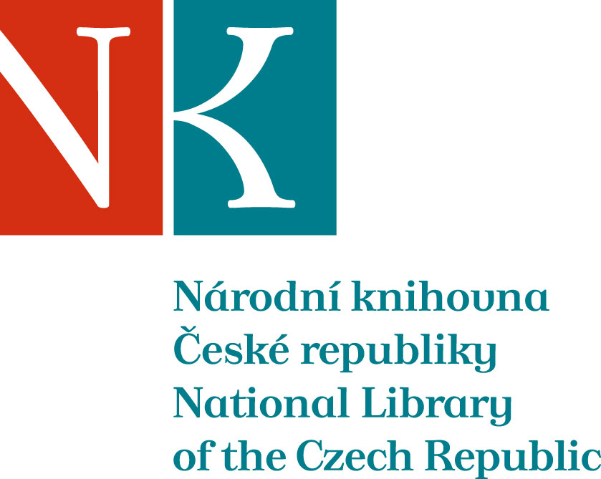

Zpráva ze zahraniční služební cesty

Jméno a příjmení účastníka cesty | Jana Dřevíkovská
Pracoviště – dle organizační struktury | OOKF 1. 4.
Pracoviště – zařazení | Oddělení restaurování 1.4.2
Důvod cesty | schůzka pracovní skupiny připravující evropský projekt LOB (Language of binding) č. 2, Ligatus Research Centre
Místo – město | Londýn, University of Arts
Místo – země | Velká Británie
Datum (od-do) | 5. - 7. 3. 2012
Podrobný časový harmonogram | 5. 3. 2012  14.15 odlet z Prahy  6. 3. 2012  9.00 - 23.00 Pracovní jednání, příprava obsahové stránky projektu  7.3 2012  9.00 - 17.00 Pracovní jednání, diskuze  21.05 odlet z Londýna, letiště Luton
Spolucestující z NK | -
Finanční zajištění | letenka, ubytování: Ligatus Research Centre, University of Arts, Prof. N. Pickwoad  diety, lístek letiště centrum a zpět: Institucionální výzkum NK ČR
Cíle cesty | příprava EU projektu
Plnění cílů cesty (konkrétně) | Proběhla pracovní schůzka plánování evropského projektu o terminologii a typologii knižních vazeb. Byly diskutovány podrobnosti k podání žádosti projektu a pět pracovních skupin pokračovalo na vytváření klíčových slov v databázi projektu LOB. Schůzka byla velmi přínosná, byly zodpovězeny hlavní otázky partnerů z různých evropských knihoven a center a vznikla příjemná komunikace mezi odborníky z různých knihoven EU. Byly navázány nové pracovní kontakty a prohloubeny kontakty z minulosti.
Program a další podrobnější informace | Podrobnější program viz program v Aj.  Setkání se účastnili zástupci těchto knihoven: The Royal Library - DK, Herzog August Library - DE, Uppsala University Library - SE, Mazarine Library - FR, Sofia University - BUL, Antwerp University - BE, FORTH - GR, National Library of the Czech Republic - CZ, National Library of Norway - NO, Tallinn University - EE, University of Osijek - HR, The National Library - PL, Trinity College - IRE, National Library of France - FR, Heritage Malta - MT, Amsterdam University - NL, Archive of the Republic of Slovenia - SI, National Bank Of Greece Cultural Foundation – GR a další...
Přivezené materiály | -
Datum předložení zprávy | 19.3.2012
Podpis předkladatele zprávy
Podpis nadřízeného
Vloženo na Intranet
Přijato v mezinárodním oddělení

Základní popis projektu v AJ:

Project description:
Books are the single most important cultural artefact produced in Europe. They not only contain much of its cultural and intellectual heritage, but they are also physical objects, each with its own history, and they survive in their millions. A book is more than the text found on its pages, and if we are fully to understand the text, we first need to understand its provenance and its use, both of which are recorded in the structure and materials of its binding. A book is a museum object as well as a means of delivering text, and the binding is a major component of that object.
From the beginning, the circulation of books and the booktrade that grew out of it were international, fostering intellectual and cultural links between countries, and their bindings bear witness to this international exchange. As the book trade expanded to cover Europe and the near east, so too the different bookmaking traditions dispersed, leading to a remarkable exchange of the styles of bookmaking between the different countries. Recording and understanding this cultural interdependence is central to this project.
To realize the rich potential of the study of bindings, we need a consistent means to describe them across Europe, and this is the aim of LoB. It will bring together book historians, bookbinders and book conservators from 17 countries from both eastern and western Europe with experts working inthe field of Semantic Web, text markup, digital libraries and digital content management.

The project aims to:
1. Develop an online tool for describing bookbindings using a predefined vocabulary,
the Ligatus Bookbinding Glossary, which is the result of a nationally-funded
research project in Britain with the approval of a panel of 15 experts from different
European countries. The online descriptive tool will be based on XML technologies
and open source software. Although this tool will be tested for bookbinding
descriptions (given the expertise of the consortium), it will be a generic tool
applicable to any object description for which a structured vocabulary exists and
therefore the same tool can be used in any other field outside bookbinding.
2. Translate the vocabulary into the language of each partner country. This will
emphasise the terminological links between different languages and the cultural links
between different traditions.
3. Deliver a critical mass of illustrated binding descriptions from a range of leading
European libraries using the developed localised online description tools.
4. Build in the necessary mechanisms to link the descriptions produced with other
leading book related databases including the CERL databases and the
Einbanddatenbank.
The consortium will include:
1. Bookbinding partners, theoretical and practical, who will provide the translation of
the vocabulary into their own languages.
2. Technical partners, who will provide expertise and develop the online descriptive
tool as well as the database with its querying tools.
3. Libraries, which will describe bindings from their collections.

Podrobný program v AJ:

Tuesday, 6th of March

9.00 – 9.45 Coffee
⇧ Sign-up for Tuesday's dinner,
⇧ update contact details.

9.45 – 10.00 Coffee and Thesaurus targets
⇧ SKOS primer,
⇧ current progress,
⇧ targets for Tuesday (coverage, scope notes with references, balance),
⇧ WebTMS improvements,
⇧ comments on communication tools.

10.00 – 13.00 Thesaurus development session
Teams as before.
WebTMS assistants as before.
Breaks when required.

13.00 – 14.00 Lunch break

14.00 – 17.00 Thesaurus development session
Teams as before.
WebTMS assistants as before (Aurelie Martin to be replaced by Ana Paula Hirata Tanaka).
Coffee to be provided at 15.00.
Breaks when required.

17.00 Announcements for Wednesday
⇧ Budgets,
⇧ nominations.

19.00 LoB dinner
Chinese restaurant (Kym's, 71 Wilton Rd., SW1V 1DE), as before, at your own expense,
as before!

Wednesday, 7th of March

9.00 – 10.00 Coffee, submissions and nominations
⇧ Sign-up for ERC one-to-one sessions,
⇧ submit ERC budgets and names (for those who have not already submitted them),
⇧ choose break-out session,
⇧ nominate 5 members for editorial committee.

9.30 – 9.40 Structure of the day

9.40 – 10.00 Report on Thesaurus development
⇧ Tuesday's progress,
⇧ report on discussions with CERL,
⇧ remaining work for initial release,
⇧ deadline for initial release.
10.00 – 10.30 Report on ERC proposal
⇧ Monday's progress.

10.30 – 10.45 Business model discussion
⇧ Presentation of possible models,
⇧ decision on model for long-term sustainability.

10.45 – 11.15 Coffee break

11.15 – 12.30 Break-out sessions
Impact activities and thesaurus adoption
⇧ Mapping of individual databases,
⇧ establishing use through institutions,
⇧ decision on dates for reports on
activities.
Manual development
⇧ The manual as an impact tool,
⇧ proposed structure,
⇧ volunteer contributors,
⇧ decision on deadline for text.

12.30 – 13.00 Reports from break-out sessions

13.00 – 14.00 Lunch break
⇧ Hand in nominations.

14.00 – 14.30 Selection of editorial committee

14.30 – 16.15 One-to-one proposal meetings
⇧ Sign-up on Wednesday morning,
⇧ please bring any budget documents which you think may be of use.

16.15 – 17.00 Discussion of proposal review
⇧ Matters arising from one-to-one proposal meetings,
⇧ volunteers for text review.

