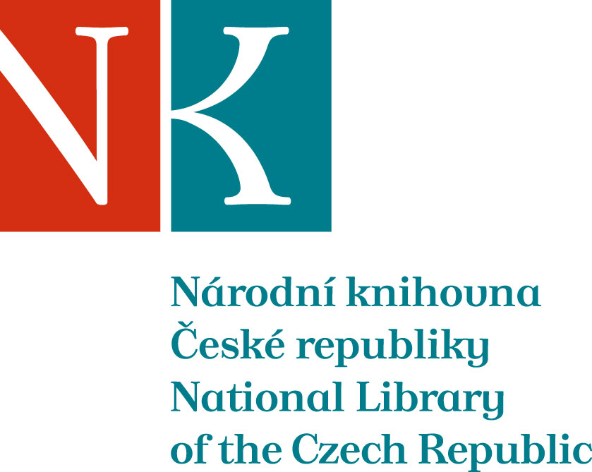

Zpráva ze zahraniční služební cesty

Jméno a příjmení účastníka cesty | Mgr. Marie Balíková
Pracoviště – dle organizační struktury | Oddělení národních věcných autorit a věcného zpracování
Pracoviště – zařazení | vedoucí oddělení
Důvod cesty | jednání exekutivního výboru konsorcia MDT
Místo – město | Haag
Místo – země | Nizozemsko
Datum (od-do) | 2.12. 2013
Podrobný časový harmonogram
Finanční zajištění | Projekt INTERPI
Cíle cesty | účast na jednáních výboru konsorcia MDT
Plnění cílů cesty (konkrétně)  jednání výboru konsorcia MDT | Program jednání výboru konsorcia MDT:  1. Opening, apologies for absence and welcome  2. To confirm the Agenda (EC 2013-09)  3. To confirm Minutes of the EC meeting 1 October 2012 (EC 2013-10) and review Action List (EC 2013-11)  4. Office and financial report  a) Report from the UDCC Chair (EC 2013-12)  b) Report from the UDCC Treasurer (EC 2013-13)  c) Office News (EC 2013-14)  5. Reports from EC Members (EC 2013-15a, 15b etc.)  6. UDC Editorial Work - report by the Editor-in-Chief (EC 2013-17)  7. UDC Online report  8. UDC Seminar report (EC 2013-18)  9. Date and location of the next meetings  10. Any other business  - Appointment of Ines Cordeiro as Executive Chairman  - Change of title of Ms Kapnisi to “Head of Office”
Přímý vztah k problematice řešené v tomto roce v projektu INTERPI | Potenciální aplikace klasifikačního systému MDT při formování znalostní báze INTERPI
Datum předložení zprávy | 9.12. 2013
Podpis předkladatele zprávy | Marie Balíková
Podpis nadřízeného | Edita Lichtenbergová
Vloženo na Intranet
Přijato v mezinárodním oddělení

Appointment of the UDCC Executive Vice-Chairman Minutes - UDC Consortium Executive Committee Meeting, The Hague, 6 May 2013, location: Koninklijke Bibliotheek, Chair: Dr. Maria Ines Cordeiro, Minutes: Ms. Sofia Kapnisi 3. Appointment of the UDCC Executive Vice-Chairman Ms Marie Balikova explained that because of the sudden illness of the UDCC Chairman Alan Hopkinson and because of the fact that he would not be able to exercise his duties in near future - the UDCC EC had to appoint an executive Vice-chairman which is an option available and covered by the UDCC Byelaws. Dr. Cordeiro who has been the UDCC business advisor for past three years and closely collaborated with Mr. Hopkinson - was contacted by the UDCC Office prior to the meeting and she agreed to take on the position. Ms Balikova explained that the objective of this item of the agenda was to provide a statement and confirmation that the Executive Committee appoints Dr. Ines Cordeiro as the UDCC Executive Vice-Chairman with immediate effect. Ms Balikova asked Dr. Cordeiro to confirm that that she would be willing to accepted this position. Dr. Cordeiro confirmed. Ms Balikova then addressed the EC reminding that prior to this meeting AENOR’s EC representative Ms Ana Maria Lopez Cano, confirmed AENOR’s approval with respect to the nomination of Dr Cordeiro. Therefore she now only asked the present UDCC EC members whether they had any objections or comments on the appointment of Dr Cordeiro. No objections and no comments were put forward. Ms Balikova concluded the nomination with the statement "following the guidelines indicated in the point 2.7 of the UDCC Byelaws, The UDCC Executive Committee has now appointed an Executive Vice-Chairman: Dr. Maria Ines Cordeiro. Based on this decision Dr. Cordeiro can take on her role as a vice-chairman with an immediate effect and administrative details of registration of Dr. Cordeiro with the Dutch Chamber of Commerce can be completed. Ms Balikova handed over the chairing of the meeting to Dr Cordeiro who thanked for the appointment and before proceeding to the next agenda suggested that the Executive Committee also approves that Ms Sofia Kapnisi is also registered with the Dutch Chamber of Commerce. This small administrative adjustment will enable Ms Kapnisi to correspond with the Chamber of Commerce on behalf of the Consortium on all urgent matters. This suggestion was accepted.

