INTERNATIONAL COMPETITION FOR THE NEW NATIONAL LIBRARY OF THE CZECH REPUBLIC

FOR THE ATTENTION OF THE MEMBERS OF THE JURY

Dear Colleagues,

In light of the complaints received from the Czech Chamber of Architects concerning the procedure followed by the jury for the above-mentioned competition, I decided to convene a meeting with the President of the Chamber to try to fully understand the position of that Chamber.

As a result of this meeting, the UIA has issued a final statement, copy of which please find attached.

I regret that the outcome of this competition has been somewhat blemished by the complaints and sincerely hope that the realisation of the winning project will in no way be impeded.

Yours sincerely,

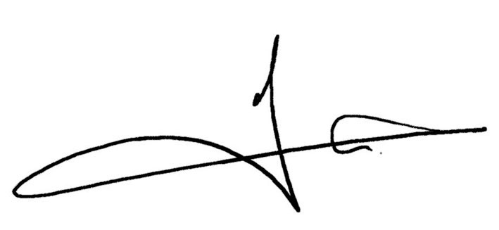

Gaëtan Siew
UIA President

Paris, 21 September 2007
Ref: c/44:07

